23. Variation and Microevolution (1) (*RHM: Chapter 21*)

______________________________________________________________________________

I. Introduction

A. Genetic Variation and Biological Evolution

B. Phenotype versus Genotype

II. Phenotypic Variation *(476-480)*

A. Phenotypic Variation in Natural Populations

B. Types of Phenotypic Variation

1. Continuous variation

2. Discrete variation

C. Quantifying the Variation

D. Causes of Phenotypic Variation

1. Genetic *versus* environmental causes

2. Importance of identifying causes

III. Non‑Mendelian Phenotypic Variation

IV. Methods for Identifying the Causes of Variation *(476-480)*

A. Two Experimental Approaches

1. Transplant experiments

2. Breeding experiments

B. Observational Studies of Polymorphisms

1. External morphology

2. Enzyme polymorphisms

C. Variation as the Raw Material for Evolutionary Change

V. The Science of Population Genetics *(480-483)*

## A. Book‑keeping

B. Usefulness to Evolutionary Biology

C. Tools of the Trade: Mathematical Models

VI. Definitions and Units of Study *(480-483)*

A. Molecular Level of Organization

B. Population Level of Organization

C. Example with Hypothetical Data

1. Calculating genotype frequencies

2. Calculating allele (= gene) frequencies

3. Calculating allele frequencies from genotype frequencies

23-1

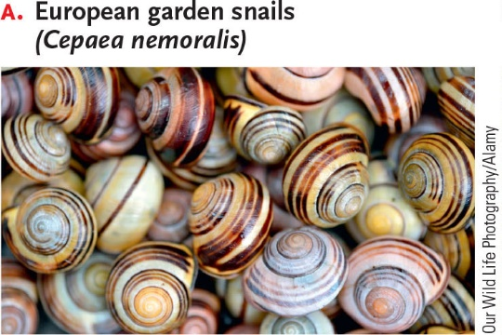 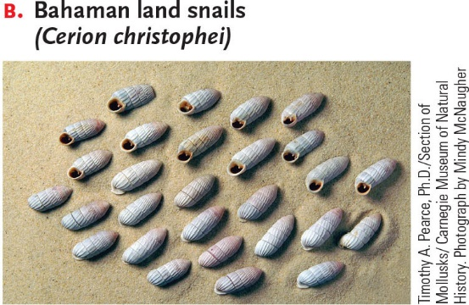

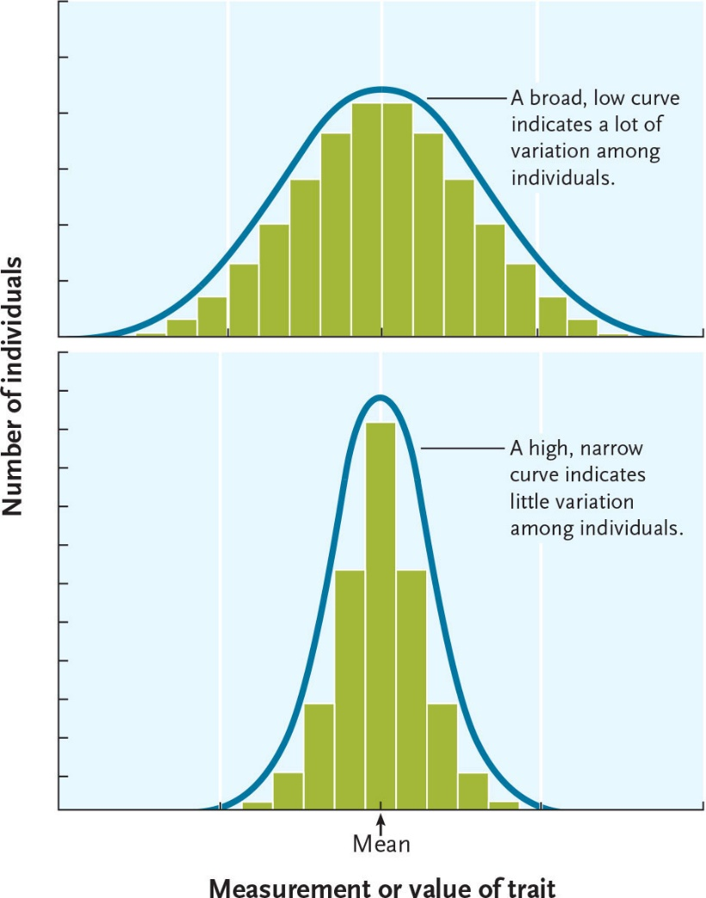

23-2

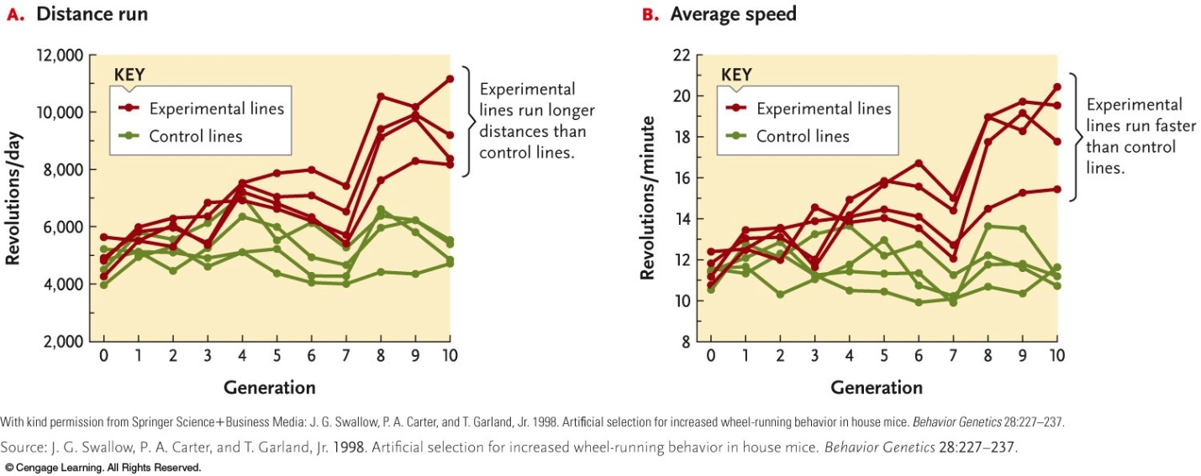

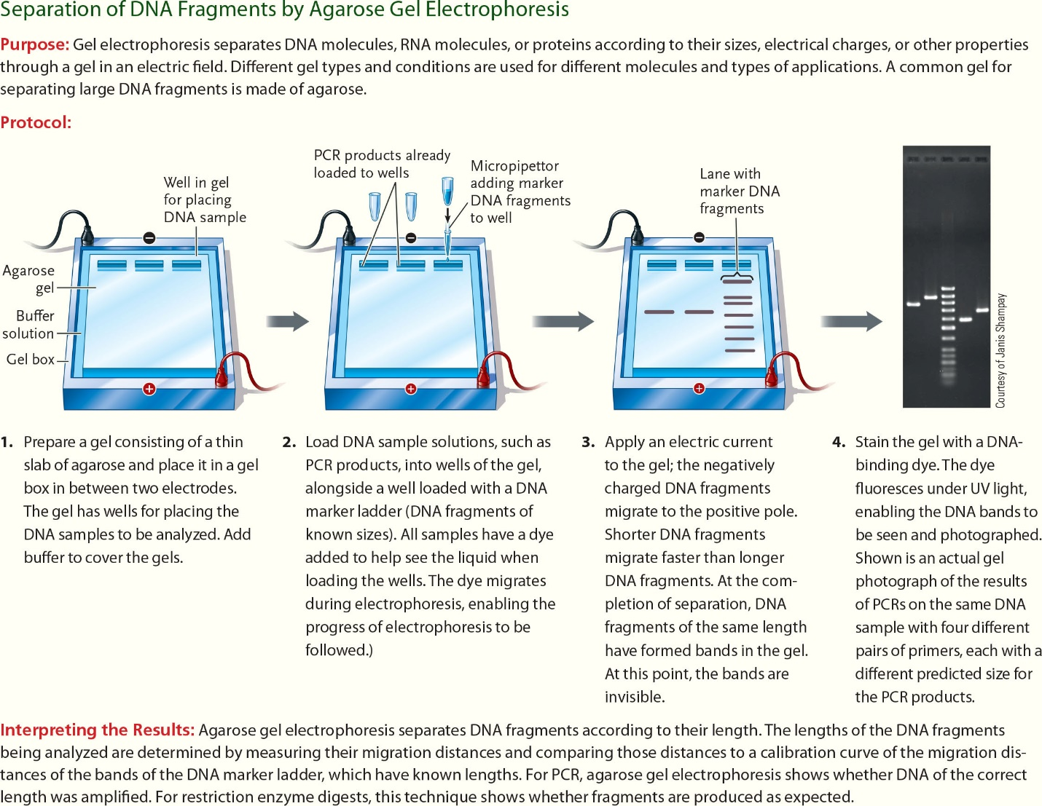

23-3

